Pancake Manor 1

Shapes are everywhere you look
Everywhere you look there are shapes
Shapes are found in everything
Everything is made up of shapes

Come on, let’s find shapes
I see a circle
I see a square
I see a triangle over there
I see a circle
I see a square
I see a triangle over there
Come on kids let’s draw shapes in the air
SQUARE
TRIANGLE
CIRCLE
SQUARE
TRIANGLE
CIRCLE
FASTER

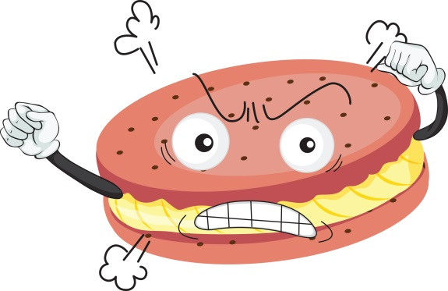
Where did you find that cookie Reggie?
Can you tell me?
I was standing by the street
I saw it lying at my feet
Should we eat it?
What do you say?
NO!!!

Where did you find that cookie Reggie?
Can you tell me?
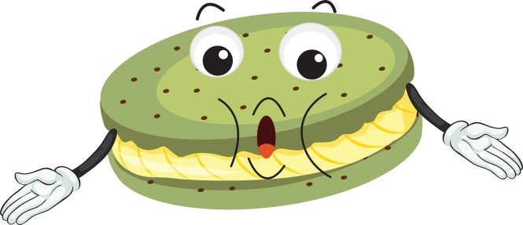
I was sitting in my favorite seat
When I saw that crusty treat
Should we eat it?
What do you say?
Yeah?
NO!!!

Where did you find the last cookie Reggie?
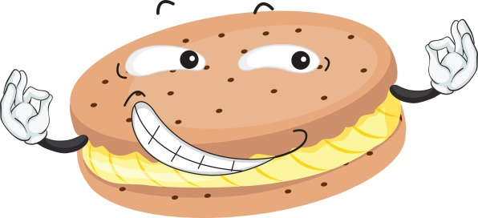
Can you tell me?
Because I was a real good boy
Mama gave me this to enjoy
Should we eat it?
What do you say?
That’s easy.
YES!!!

Cookies dance (7)
YEAH!

Things go up
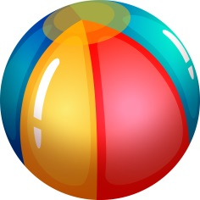
Then things come down
Up in the air
Down to the ground
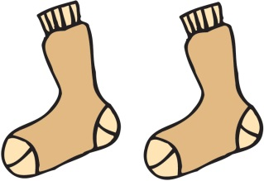
Toss a ball up in the air
It goes up and down
Throw a sock up in the air
It goes up and down
Look around and see
UP!
DOWN!

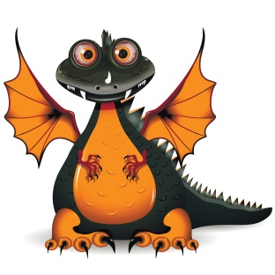
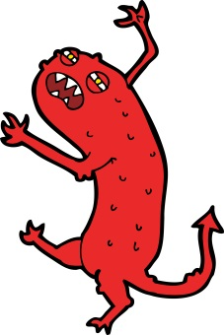
Things go up
Then things come down
Up in the air
Then down to the ground
Toss a monster in the air
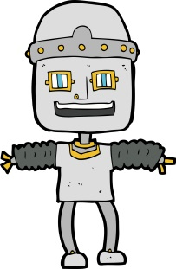
It goes up and down
Fling a dragon in the air
It goes up and down
Throw a robot in the air
It does up and down
Now let go of your balloon
And watch it go up
And down
Look around and see
UP!
DOWN!
UP!
DOWN!

I can’t wait until we fly
Way up there in the cloudy sky
Close your eyes
And think of a place
Somewhere fun
Where to?
How about outer space
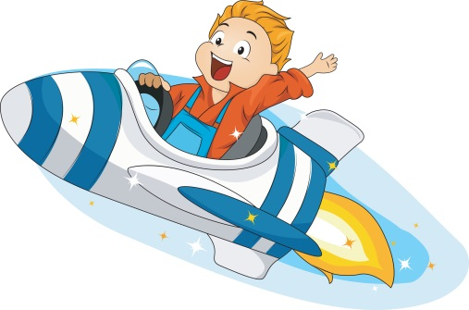
You know I always wanted to visit the moon
Me too, so I packed some grapes
Good thinking
Alright Captain, we’re ready for launch

Super Turbo Flying Machine
Take me places that I have never seen
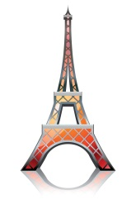
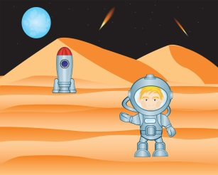
We’ve seen France
C’est bon!
We’ve seen Mars
Très bien
The pyramides
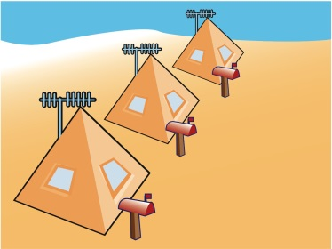
And a few RINGO stars
It’s getting late
Really late
It’s time for bed
Let’s fly back home
Ok
And lay down our sleepy head

Super Turbo Flying Machine
Take me places that I have never seen

BIG
small
BIG
small
Some things are very big
Some things are very small
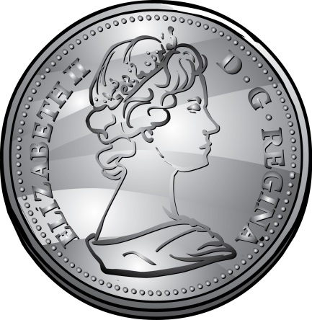
You can see them everywhere
Just look around it’s not hard at all

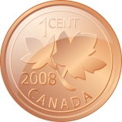
What about this shiny coin
I’d say it’s small
What about this shiny coin
Wow, it’s bigger than a house
It must be

BIG
small
BIG
small
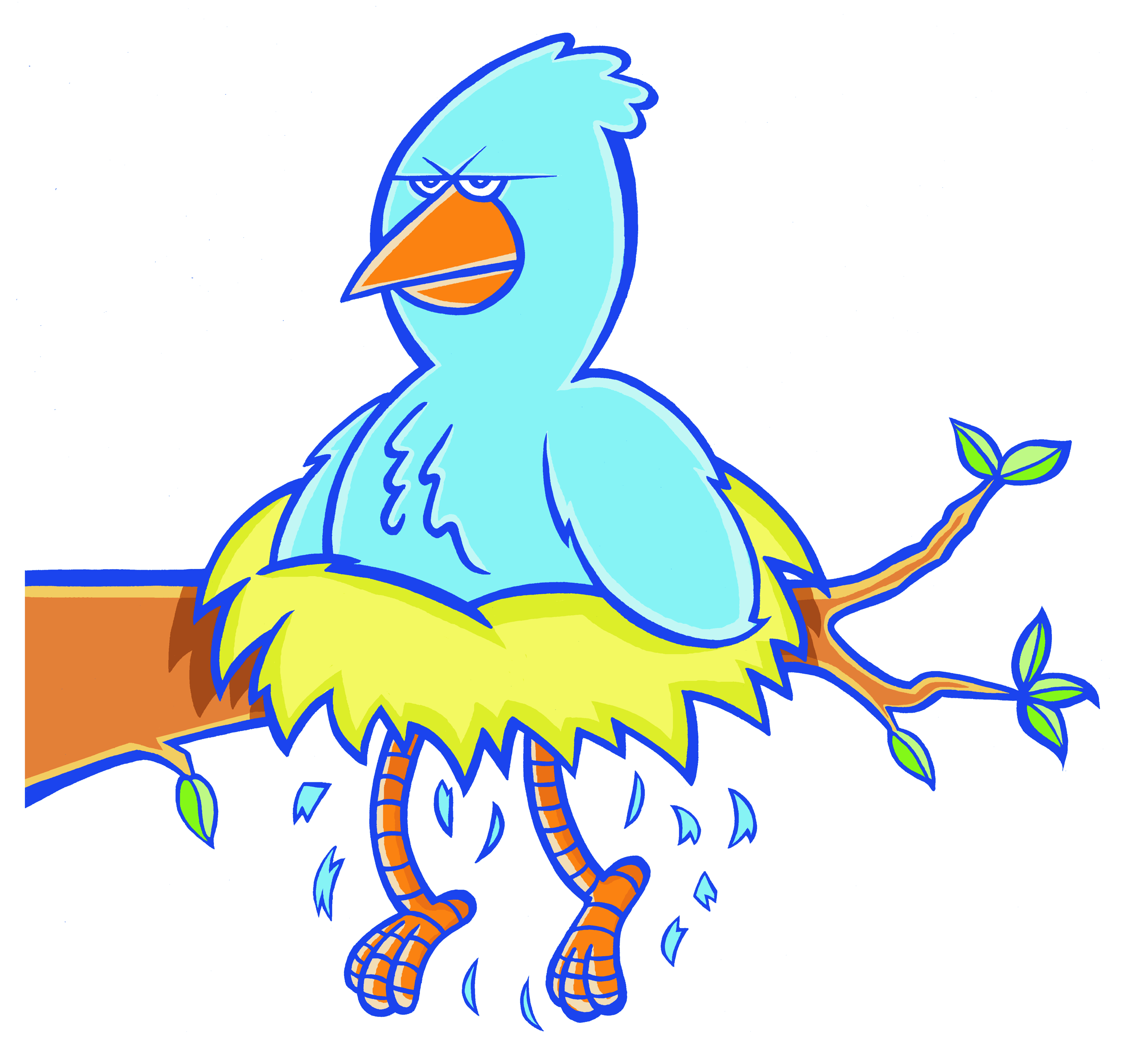
What about this really cute bird
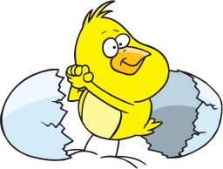
I’d say it’s small
What about this cute bird
Wow it’s bigger than plane
It must be

BIG
small
BIG
small
BIG
small
BIG
small

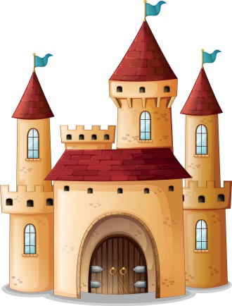
I’m a knight as you can see.
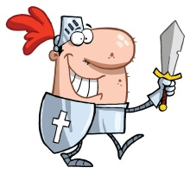
I have a sword and a shield on me
Look at my castle it’s made of stones
I live in England and it’s my home

But something’s missing
What could it be?
I can draw it
There we go, I’m a dragon
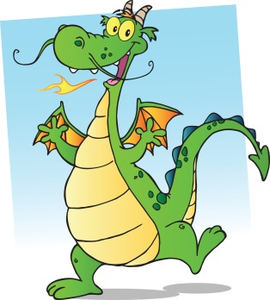
I’m a dragon as you can see
I have wings and a tail on me
Look at my mouth
I breathe fire
I burn castles and I never get tired

But something’s missing
What could it be?
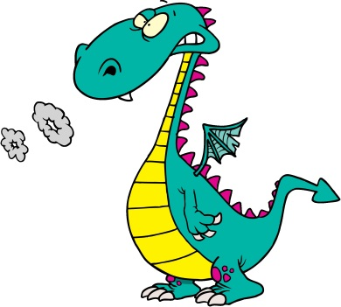
I can draw it
There we go, a bucket of water

I’m a knight as you can see.
I have a bucket of water with me
Mr. Dragon, leave me alone
I splash your fire and protect my home

Hey look!
Look there flying in the air
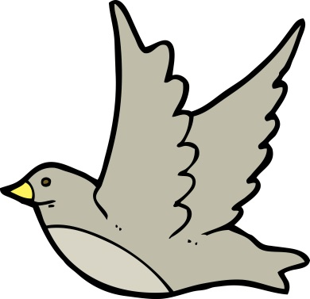
It looks like a bird
Look high soaring through the sky
It might be a bird
And we’ll know because

Birds have beaks
Birds can sing
They’ve got lots and lots of feathers on their wings

Look there flying in the air
It must be a bird
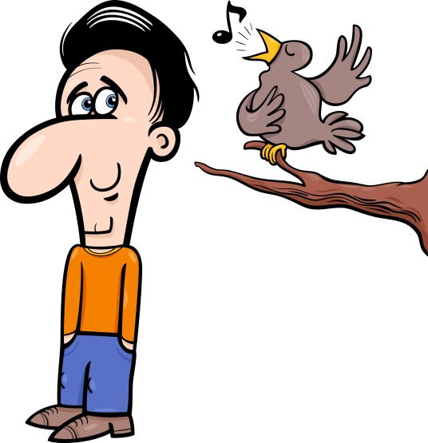
Move your arms like a bird
Move your arms like a bird
Sing a song like a bird
Tweet, tweet, tweet
Sing a song like a bird
Tweet, tweet, tweet

Move your arms like a bird
Now sing a song like a bird
Tweet, tweet, tweet
Now move and sing like a bird
Tweet, tweet, tweet
Now move and sing like a bird
Tweet, tweet, tweet

Alright
Birds have beaks
Birds can sing
They’ve got lots and lots of feathers on their wings
Look there flying in the air
It must be a bird

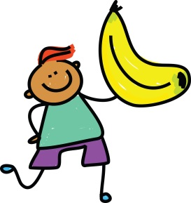
Would you like a banana Reggie?
Don’t you think it would be so yummy?
How do we know that’s ready to eat?
Good question!
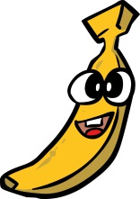
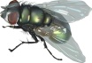
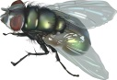
Is it green? Take a look
It should be yellow
It is squished covered in flies
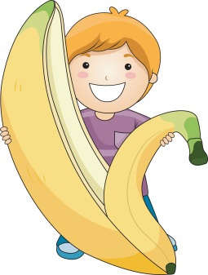
NO!!!

Then we are ready to go
Now we know that it is ready to eat
The next step will make it all complete
Peal the banana like so

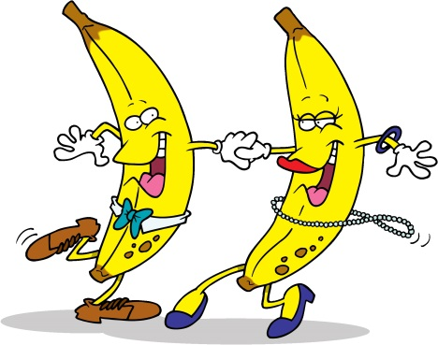
We are bananas for bananas
We are bananas for bananas
We are bananas for bananas

One, one is a number
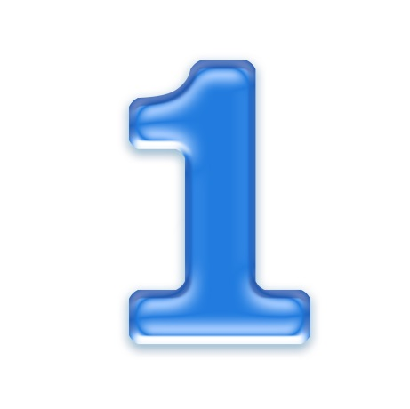
Two’ two’s the next number
Three, three’s the third number
One, two, three
One, one Reggie
Two, two Reggies
Three, three Reggies
One, two, three

When we sing it out
Counting is so easy
When we sing it out
Counting’s easy breezy
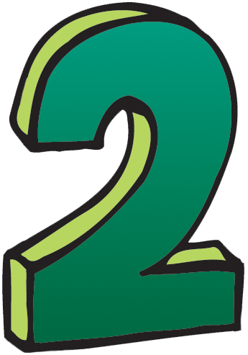
Sing with me
One, two, three
One, two

How many Reggies do you see?
How many of me?
ONE!!!
Alright
How many Reggies do you see?
How many of me?
How many of me?
TWO!!!
Alright
How many Reggies do you see?
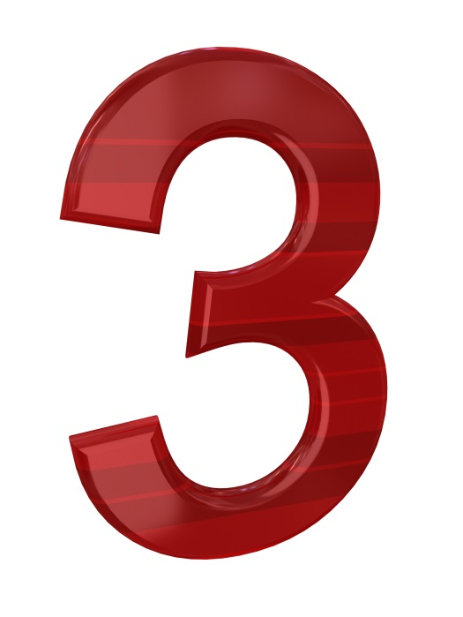
How many of me?
How many of me?
How many of me?
THREE
Alright
Alright

One, one is a number
Two, two’s the next number
Three, three’s the third number
One, two, three
When we sing it out
Counting is so easy
When we sing it out
Counting’s easy breezy
Sing with me
One, two, three

OK! Follow my lead
Here we go
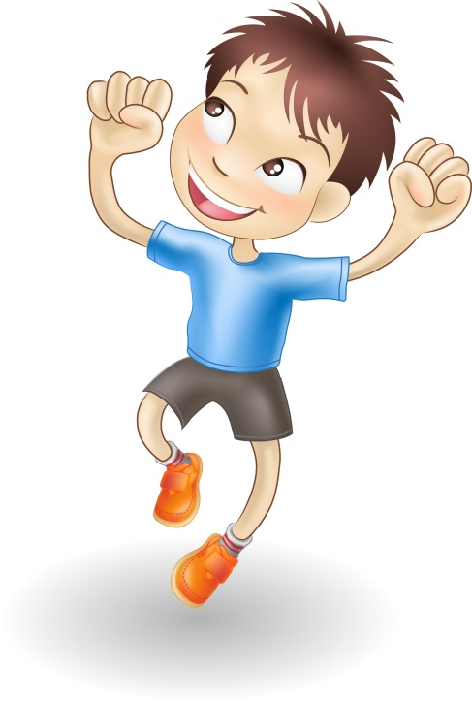
Shake, shake, everybody shake
Now jump, jump, jump, jump off the ground
Now shake, shake everybody shake
Now jump, jump, jump, jump off the ground
And turn around

Keep going
Shake, shake, everybody shake
Now jump, jump, jump, jump off the ground
Now shake, shake, everybody shake
Now jump, jump, jump, jump off the ground
And turn around

Shake, shake
Jump, jump, jump
Shake, shake
Jump, jump, jump
Shake, shake, shake
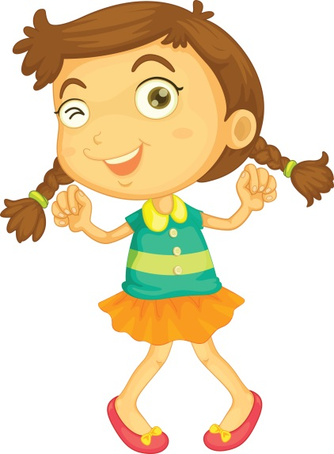
Jump, jump, to jump
Shake, shake, shake, shake, shake
Jump, jump, jump, jump, jump,
Turn around

Shake, shake everybody shake
Now jump, jump, jump, jump off the ground
Now shake, shake, everybody shake
Now jump, jump, jump, jump off the ground
Shake, shake, everybody shake
Now jump, jump, jump, jump off the ground
Now shake, shake, everybody shake
Now jump, jump, jump, jump off the ground
Shake, shake everybody shake
Now jump, jump, jump, jump off the ground
Now shake, shake, everybody shake
Now jump, jump, jump, jump off the ground
And turn around

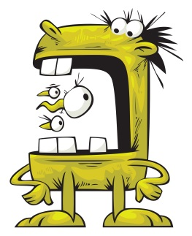
This monster’s never bored
His teeth are sharper than a sword
This monster’s head is squared
Like a box and he doesn’t care
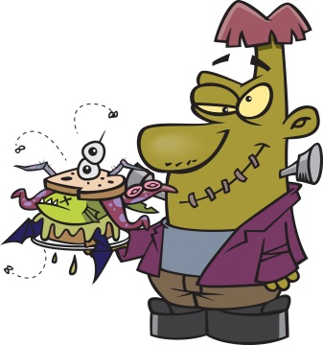
This monster has big feet
He stomps them down when he walks the street
This monster wears a suit
He loves his cat, it’s pretty cute

I like your monster Zachary
Thank you Reggie that was nice
What do you think he sounds like?

Well, looks like I’m late for work again Brian
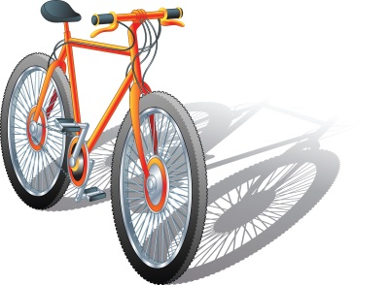
Meow!
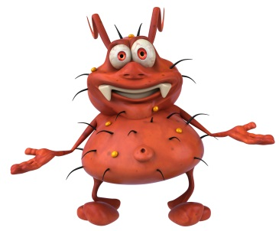
This monster has big eyes
He can see the smallest flies
This monster rides a bike
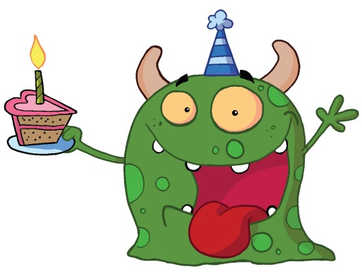
Rides around anywhere he likes
This monster’s nose is red
It turns blue when he goes to bed
This monster love his cakes
He eats a lot because he bakes

I like your monster Zachary
Thank you Reggie that was nice
What do you think he sounds like?

I went for a very long ride on my bicycle
Then I bought the ingredients for this cake

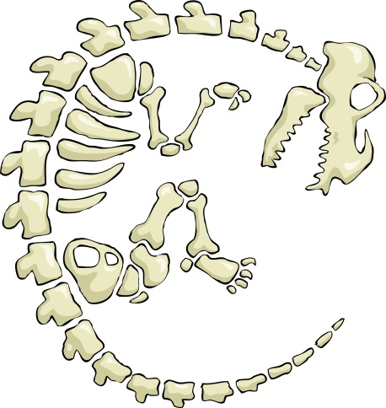
Dinosaur bones, yeah
We want to see them
Dinosaur bones, yeah
We want to see them
Dinosaur bones, yeah
We want to see them
Dinosaur bones, yeah
Where can we want to see them?
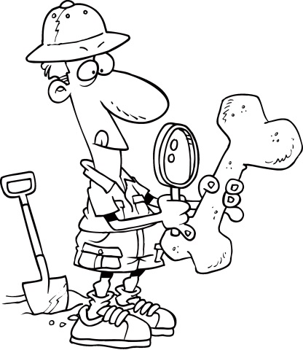
Let’s go out, let’s find that dinosaur
I hear they are found outdoors
We’ll have to look around
We’ll have to look on the ground
And when we find those bones
We’re gonna have to take them
To a Museum
It’s just the right thing to do

Dinosaur bones, yeah
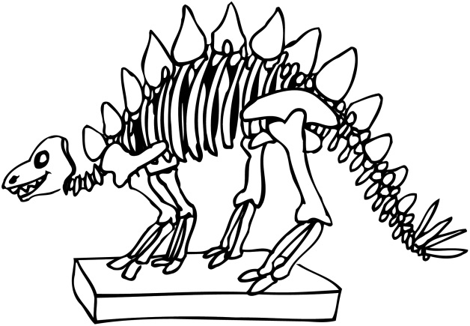
Find them in the Museum
Dinosaur bones, yeah
So the people can see them
Dinosaur bones, yeah
Find them in the Museum
Dinosaur bones, yeah
So the people can see them

