Pancake Manor 2

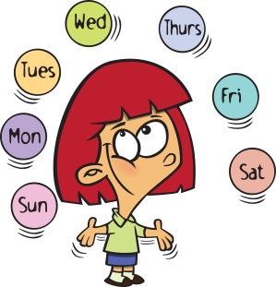
It's now Saturday
Wake up, wipe the sleep from your eyes
It's our favourite day
Mama's gonna make us a treat when we rise
STEP ONE
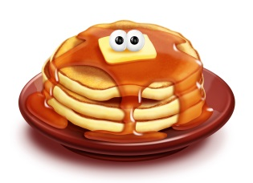
You pour it
Pancake Party
STEP TWO
Then you flip it
STEP THREE
Then you stack it, higher and higher
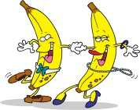
It's a Pancake Party
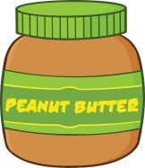
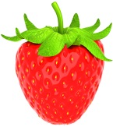
What a way to wake up
It's a Pancake Party
Pour that syrup
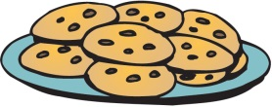
Strawberry
Banana
Peanut Butter
Chocolate Chips
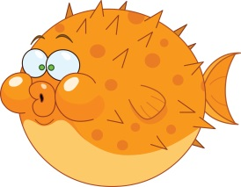
Blueberry
Fish
(Just kidding)
STEP ONE
You pour it
STEP TWO
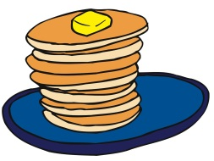
You flip it
STEP THREE
You stack it, higher and higher
It's a Pancake Party
What a way to wake up
It's a Pancake Party
Pour that syrup
It's a Pancake Party
What a way to wake up
It's a Pancake Party
Pour that syrup

Count to 10
1 2 3 4 5
6 7 8 9 10

1 2 3 4 5
6 7 8 9 10

1 2 3 4 5
6 7 8 9 10

1 2 3 4 5
6 7 8 9 10

1 2 3 4 5
6 7 8 9 and 10
Let’s do it again
1 2 3 4 5
6 7 8 9 and 10
Let’s do it again
1 2 3 4 5
6 7 8 9 and 10
Let’s do it again
1 2 3 4 5
6 7 8 9 and 10
Let’s do it again
1 2 3 4 5
6 7 8 9 and 10
Let’s do it again
1 2 3 4 5
6 7 8 9 and 10
Let’s do it again

We live in a solar system
The Planets
In the center is the sun
All the planets move around it
We’ve seen every single one
Orbiting the big bright sun
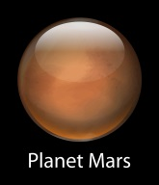
Orbiting the big bright sun
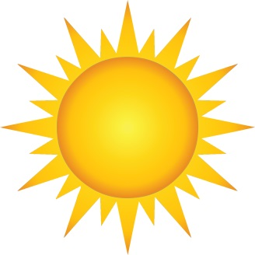
Planets in our solar system
1 2 3 4 5 6 7 8
Telescopes they help us see them
We’ve seen every single one
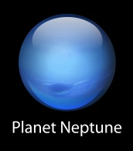
Orbiting the big bright sun
Orbiting the big bright sun

Mercury
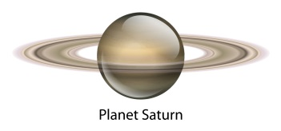
Venus and Earth, then Mars
Then Jupiter
And Saturn
Uranus too
And don’t forget that pretty blue Neptune

We live in a solar system
In the center is the sun
All the planets move around it
We’ve seen every single one
Orbiting the big bright sun
Orbiting the big bright sun

You might say I’m a normal kid
Superhero
Most of the time I guess I am
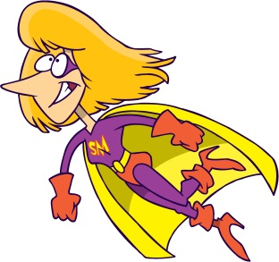
But if there’s trouble I’ll be there
I have just that thing to wear

I’m a superhero
Look at me go
I’m a superhero
Look at me go
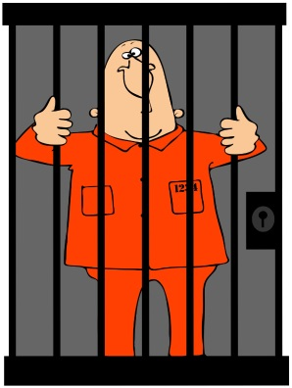
Flying through the sky
Fighting the bad guys
There’s no need to fear
Cause I’ll be here
I’ll be your superhero

Flying through the sky
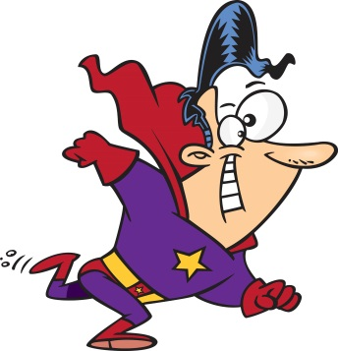
Fighting the bad guys
There’s no need to fear
Cause I’ll be
Flying through the sky
Fighting the bad guys
There’s no need to fear
Cause I’ll be here
I’ll be your superhero

Look at me go
I’m a superhero
Look at me go

1 + 1 is 2
1 + 1
2 + 1 is 3
3 + 1 is 4
4 + 1 is 5

1 + 1 is 2
2 + 1 is 3
3 + 1 is 4
4 + 1 is 5

Then we are counting one by one
We are adding
And it’s so much fun
So fun

1 + 1 is 2
2 + 1 is 3
3 + 1 is 4
4 + 1 is 5

1 + 1 is 2
2 + 1 is 3
3 + 1 is 4
4 + 1 is 1 2 3 4 5

Move your legs
Legs and Arms
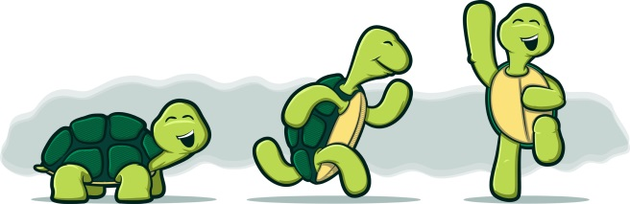
Move them up and down
Move your arms
Move them up and down
Legs! Arms!
Move them all around
Legs! Arms!
Move them all around and around and you
FREEZE
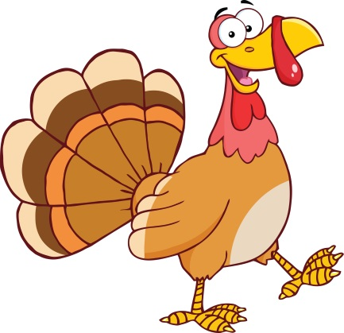
Move your legs
Move them up and down
Move your arms
Move them up and down
Legs! Arms!
Move them all around
Legs! Arms!
Move them then you FREEZE

Wave your arms
Wave them super slow
Lift your legs
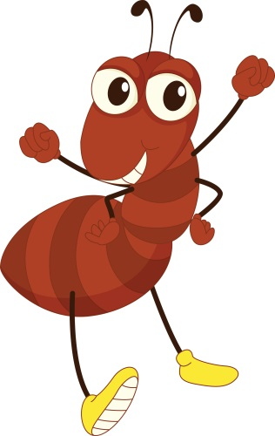
Lift them

Now go crazy
Legs! Arms!
Crazy legs and arms
Legs! Arms!
Crazy legs and arms
Legs! Arms!
Crazy legs and arms
Legs! Arms!
Go crazy going round and around
And you FREEZE

There are four seasons
The Seasons
That happen in a year
Spring, summer, autumn, winter
Spring, summer, autumn, winter
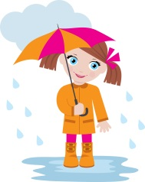
Four seasons that happen in a year
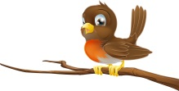
Spring, summer, autumn, winter
Spring, summer, autumn, winter

Can you tell me what season it is?
Let’s take a look
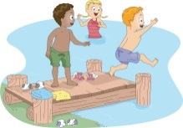
Flowers, rain and birds: SPRING
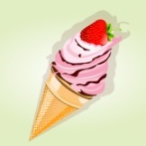
Can you tell me what season it is?
Let’s take a look
Ice cream, swimming and sun: SUMMER
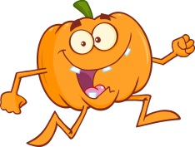
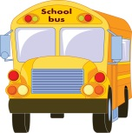
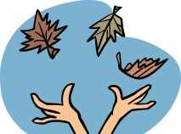
Can you tell me what season it is?
Let’s take a look
School bus, pumpkins and leaves: AUTUMN
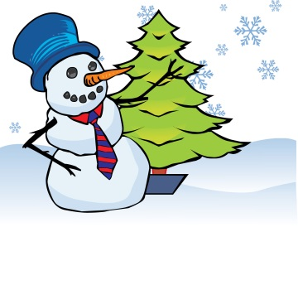
Can you tell me what season it is?
Let’s take a look
Snowflakes in the air: WINTER

There are four seasons
That happen in a year
Spring, summer, autumn, winter
Spring, summer, autumn, winter

You throw this ball through the hoop
Sports Balls
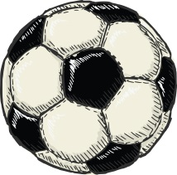
A BASKETBALL
You kick this ball through the goal
A SOCCER BALL
You hit this ball over the net
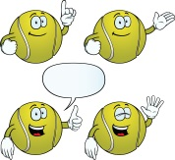
A TENNIS BALL
You hit this ball over a tiny net
A TABLE TENNIS BALL
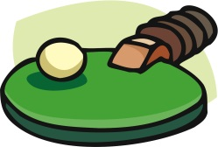
Let’s bounce like a ball
Bounce, Bounce, Bounce
Bounce, Bounce, Bounce
Bounce, Bounce
Like a ball
Bounce, Bounce, Bounce
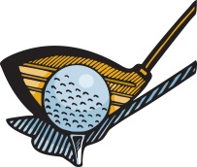
You hit this ball with a club
A GOLF BALL
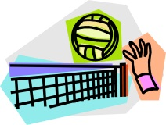
You spike this ball with you hand
A VOLLEYBALL
You hit this ball with a bat
A BASEBALL
You’ll find this ball at the beach
It’s A BEACH BALL
Let’s bounce like
Let’s bounce like
Let’s bounce like a ball
Bounce, bounce, bounce
Bounce, bounce, bounce
Bounce, bounce, bounce,
Bounce, bounce, like a ball
Bounce, bounce, bounce
Bounce, bounce like a ball
Bounce, bounce, bounce
Bounce, bounce, bounce

I have a name
Names
What is your name?
My name is Zack
I have a name
What is your name?
My name is Reggie
You have a name
Let’s hear it!
What is your name?
Every person that you know
Has a name
And every place that you can go
You’ll hear names
There’re so many names
My name is Rupert… Hello!
My name is Ziggy… Please to meet you!
My name is Andy …Cheers!
Mt name is Stella … Hi!
What’s my name? Rupert
What’s my name? Ziggy
What’s my name? Andy
What’s my name? Stella

There are so many names
There are o many names
There are so many names

I have a name
What is your name?
Zack
I have a name
What is your name?
My name’s Reggie
You have a name
Let’s hear your name
We all have names
Let’s hear your name
We all have names
Let’s hear your name
Let’s hear your name

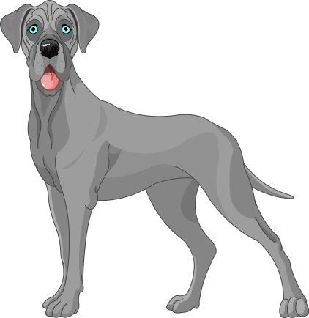
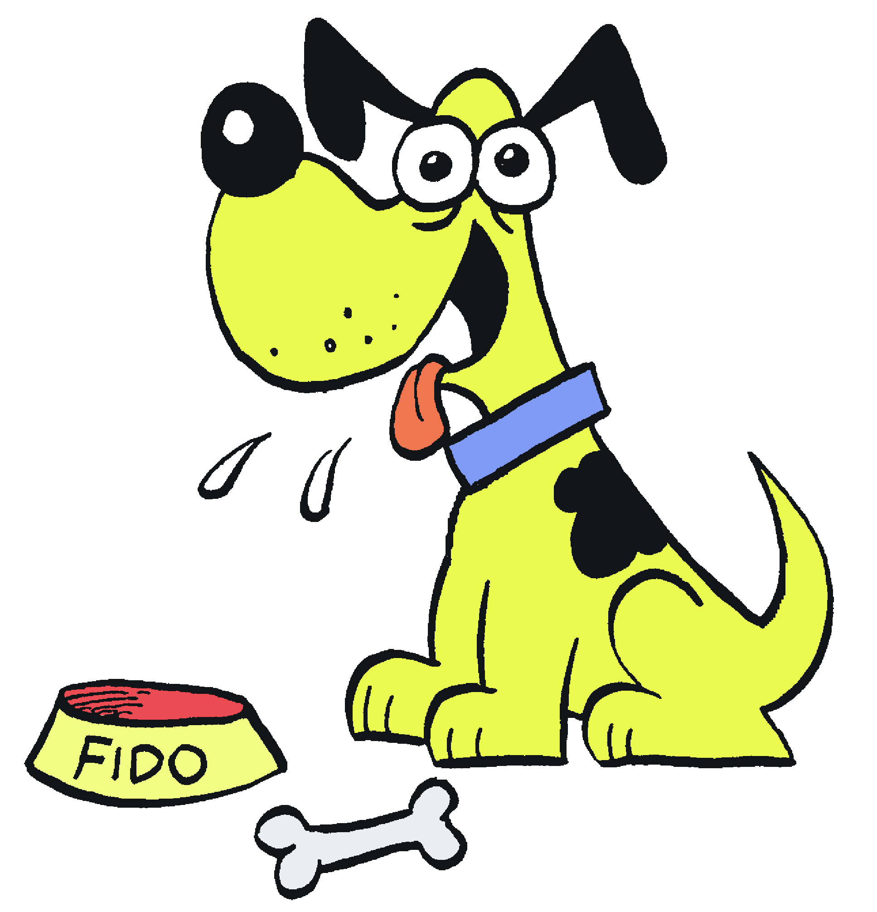
Dogs are playful
Dogs
Dogs like to bark
Dogs have wagging tail
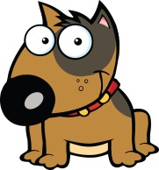
When they walk in the park

Some dogs are short SHORT!
Some dogs are tall TALL!
Dogs really like when you throw them a ball

I love dogs
I love dogs, I love them
I love dogs
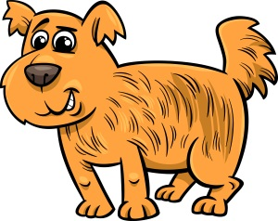
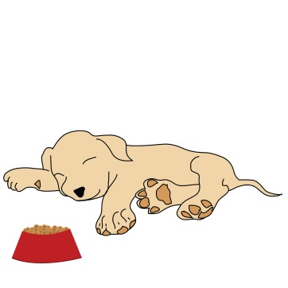
I love dogs, I love them

Dogs are hairy
Some dogs get dressed
If they’re sleepy they like to take a rest
Dogs drink water
They eat dog food
They’ll eat your sandwich
Hey that’s rude
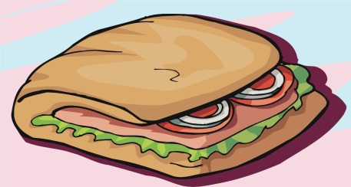
I love dogs
I love dogs, I love them
I love dogs
Even the one who ate my sandwich

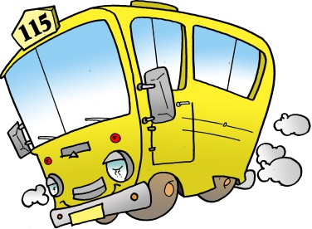
The wheels on the bus go round and round.
Wheels on the Bus
Round and round.
Round and round.
The wheels on the bus go round and round,
All through the town!

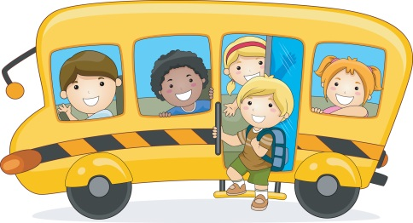
The doors on the bus go open and shut
Open and shut
Open and shut
The doors on the bus go open and shut
All through the town!

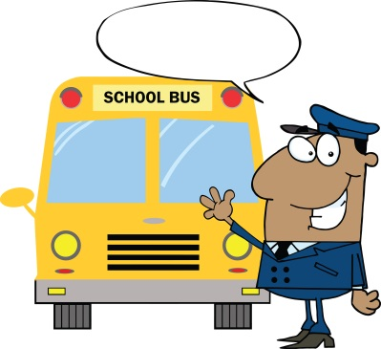
The motor on the bus goes zoom, zoom, zoom
ZOUM
Zoom, zoom, zoom
Zoom, zoom, zoom
The motor on the bus goes zoom, zoom, zoom
All through the town!

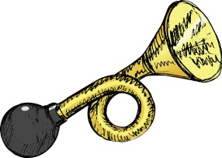
The horn on the bus goes beep, beep, beep.
Beep, beep, beep.
Beep, beep, beep.
The horn on the bus goes beep, beep, beep.
All through the town!
The wheels on the bus go round and round.
Round and round.
Round and round.
The wheels on the bus go round and round,
All through the town!

It’s your birthday
Birthday Song
It’s your birthday
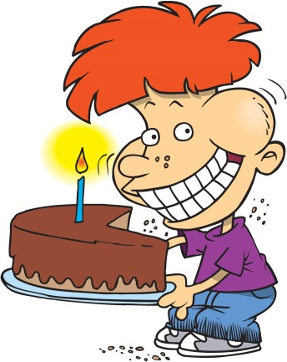
Happy birthday to you
It’s your birthday
It’s your birthday
Happy Birthday to you

Because you’re one year older
A cake for you
Because you’re one year older
A present for you
It’s your special day
So we get together and say
We love you
We love you

It’s your birthday
It’s your birthday
Happy birthday to you
It’s your birthday
It’s your birthday
Happy Birthday to you

Happy, happy birthday
It’s your birthday
Happy, happy birthday
It’s your birthday
Happy, happy birthday
Happy Birthday to you

Once upon a time there was a little girl named Goldilocks.
She went for a walk in the forest.
Pretty soon she came upon a house.
She knocked and when no one answered, she walked right in.
WHAT! Mama would not like that .
At the table there were three bowls of porridge
Goldilocks was hungry, so she decided to try every bowl.
Goldilocks
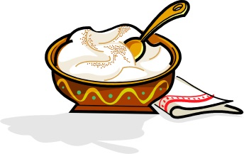
This porridge is too hot
This porridge is too cold
This porridge is just right
And I’m gonna eat it all up.
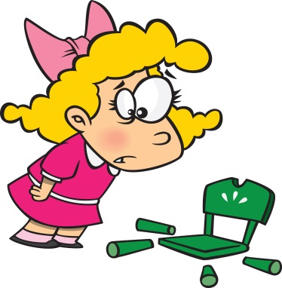
Then Goldilocks decided to sit down.
There were three chairs in the living room.

This chair is too wide
This chair is too long
This chair is just right
And I’m gonna sit down on….Woopsy daisy

Goldilock was very tired by this time so she when to the bedroom
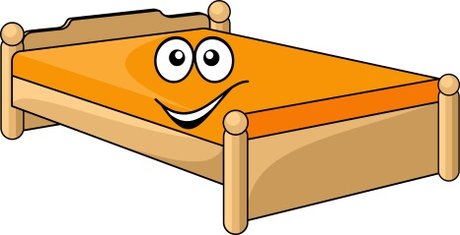
This bed is too hard
This bed is too soft
This bed is just right
And I’m gonna sleep in it all night
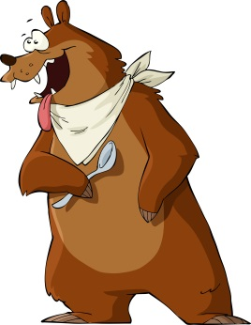
Then the owners of the home came back

Someone’s been eating my porridge
Someone’s been eating my porridge
Someone’s been eating my porridge and they ate it up

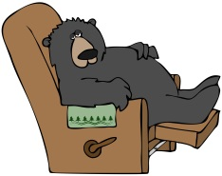
Someone’s been sitting in my chair
Someone’s been sitting in my chair
Someone’s been sitting in my chair and they broke it up

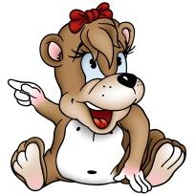
Someone’s been sleeping in my bed
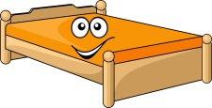
Someone’s been sleeping in my bed
Someone IS sleeping in my bed

What do you think happened next?

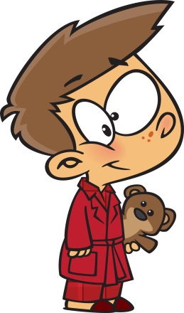
Oh it’s time to go to sleep
Bedtime Story
It’s time to go to bed
At the end of the day
We need to rest our heads

First we need to take a bath
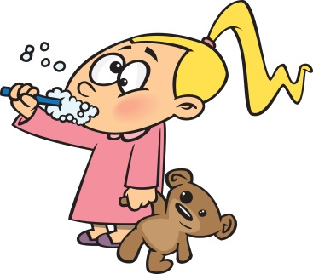
Then we put on our PJs
Then we need to brush our teeth
And we’re almost half way there

It’s time to go to sleep
It’s time to go to bed
At the end of the day
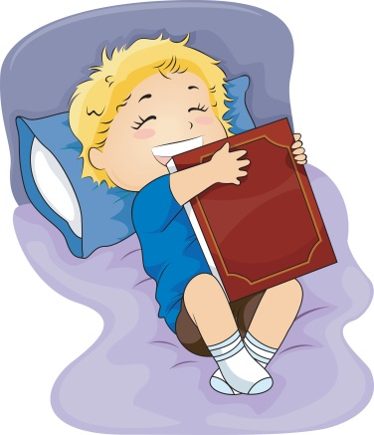
We need to rest our heads

We snuggle under the covers
Then we read a story book
One more thing before we dream
We always get a kiss good night

We went to sleep
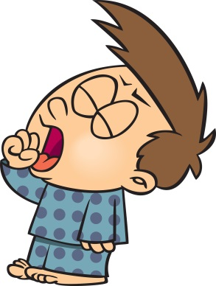
We went to bed
We went to sleep
We went to bed
We went to sleep
We went to bed
We went to sleep
We went to bed

