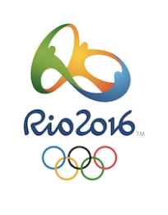
Rio 2016 WebQuest
A Challenging Quest About the 2016 Summer Olympic Games
http://webquestrio2016.weebly.com

THE HISTORY

The Flag and the Rings
- The colours of the rings are: red, blue, green, yellow, black.

- The six colours of the flag represent: The 6 colours are those that appear on all the national flags of the world at the present time.

Past Olympic Games
- Where did the Olympics take place in 2004? In Athens
- Where did the Olympics take place in 1988? (2) Calgary / Seoul
- Where did the Olympics take place in 1976? (2) Montreal / Innsbruck
- The Olympics were cancelled in the years 1940 and 1944. Why?
They were cancelled because of World War II.
- How many days are left until the Rio Olympic Games? Answers will vary

RIO DE JANEIRO

Where is Rio?
- In which continent is Rio de Janeiro? In South America
- In which country is Rio de Janeiro? In Brazil
- Are these the first Olympic Games on this continent? Yes

About the competitions, sports, and athletes in Rio.
- How many athletes will compete in Rio? 10,500 athletes
- How many countries will participate? 206 countries
- How many sports will be contested? 42 sports
- What are the two new sports in these Olympics?
Golf Rugby

There are four regions in the city where the competitions take place.
Name the 4 regions:
Copacabana Maracana Barra Deodoro
​
- Name five summer sports that you like to watch.
_________ Answers will vary _______________________________
________________________________ _______________________________

THE TORCH

The Rio 2016 Olympic Torch
- What is it made of? Recycled aluminium
- What are the colours of the Brazilian flag that you find in Rio's torch?
Blue, green, yellow (or golden), white. (There is some black in the torch)
I gave one point if three colours were mentioned.
- What do the 4 sections symbolize? 4 answers:
The sky, the mountains, the sea and the ground.
- What is the "kiss of the torches"? When the flame passes from one runner (or torch bearer) to another.
- Do you like this torch and its design? Answers will vary.
Explain in a few words. Answers will vary. ( Its design, its colours. It is futuristic. It is original and beautiful. It can expand. It’s environmentally safe)

The relay of the torch
- Complete the sentence:
"The torch will pass through 300 towns and cities in its 100 -day journey."

THE MASCOTS

The Evolution of the Olympic Mascot
- When did the first Mascot appear? In 1972
- Write the name of three famous Olympics mascots. Answers will vary. Students should write names of previous mascots that they have chosen in the Photo Gallery.
- Look at the pictures of different mascots from previous Olympic Games.
Which mascot do you like best? Answers will vary. Vicinius and Tom are not correct answers.
Why? Answers will vary.
- Rio Mascots
- Who are Vinicius and Tom in Brazil? They are two famous musicians in Brazil: Vinicius de Moraes and Tom Jobin. Also: Vinicius is a poet of Bossa Nova and Tom is musical maestro who sang all the charms of Brazil.
- What is the inspiration for these mascots?
They are inspired by the various animals and plants found in Brazil.
- Who is the Olympic Games mascot? Vinicius
- Who is the Paralympic Games mascot? Tom
- Which one do you prefer? Vinicius OR Tom
Why? Answers will vary. For example: Because he looks funny and I really like him. His hair looks like peacock feathers.

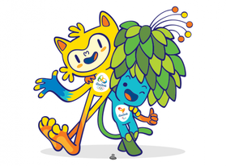
- One point per question
Total : /30 points

