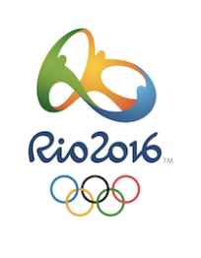
Rio 2016 WebQuest
A Challenging Quest About the 2016 Summer Olympic Games
http://webquestrio2016.weebly.com

THE HISTORY

The Flag and the Rings
- The colours of the rings are:
_____________ _____________ ______________ _____________ _____________

- The six colours of the flag represent: ____________________________________________________________________

Past Olympic Games
- Where did the Olympics take place in 2004? ________________________________
- Where did the Olympics take place in 1988? (2) _____________ _______________
- Where did the Olympics take place in 1976? (2) _____________ _______________
- The Olympics were cancelled in the years 1940 and 1944. Why? ________________
____________________________________________________________________
- How many days are left until the Rio Olympic Games? _________

RIO DE JANEIRO

Where is Rio?
- On which continent is Rio de Janeiro? _____________________________________
- In which country is Rio de Janeiro? _______________________________________
- Are these the first Olympic Games on this continent? Yes / No

The competitions, sports, and athletes in Rio.
- How many athletes will compete in Rio? ___________________________________
- How many countries will participate? ______________________________________
- How many sports will be contested? _________ _____________________________
- What are the two new sports in the Rio Olympics?
________________________ _________________________
- There are 4 regions in the city where the competitions take place.
Name all 4 regions:
________________________________ _______________________________
________________________________ _______________________________
​
- Name 5 summer sports that you like to watch.
________________________________ _______________________________
________________________________ _______________________________
________________________________
THE TORCH

The Rio 2016 Olympic Torch
- What is it made of? ____________________________________________________
- What are the colours of the Brazilian flag that you find in Rio's torch? ____________________________________________________________________
- What do the 4 sections symbolize? (4):
__________________ _______________ ________________ _______________
- What is the "kiss of the torches"? _________________________________________
____________________________________________________________________
- Do you like this torch and its design? __________
Explain in a few words. _________________________________________________
____________________________________________________________________

The relay of the torch
- Complete the sentence:
"The torch will pass through _________ towns and cities in its ___________ -day journey."

THE MASCOTS

The Evolution of the Olympic Mascot
- When did the first Mascot appear? ________________________________________
- Write the names of 3 famous Olympics mascots.
______________________ ________________________ _________________
- Look at the pictures of different mascots from previous Olympic Games.
Which mascot do you like best? ________________________________________
Why? _____________________________________________________________
2016 Rio Mascots
- Who are Vinicius and Tom in Brazil? ______________________________________
- What was the inspiration for these mascots? ______________________________
___________________________________________________________________
- Who is the Olympic Games mascot? ______________________________________
- Who is the Paralympic Games mascot? ____________________________________
- Which one do you prefer? _______________________________________________
Why? _______________________________________________________________
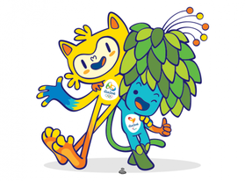

Great work!
And the winner is…

