

**Service de garde**

20 octobre 2017

« une journée monstrueuse! »

[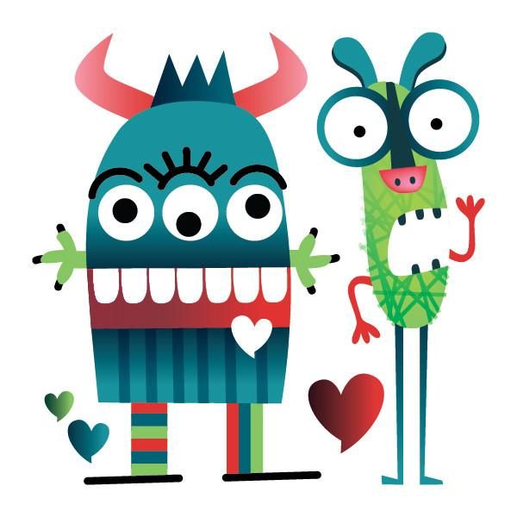](https://www.google.ca/url?sa=i&rct=j&q=&esrc=s&source=images&cd=&cad=rja&uact=8&ved=0ahUKEwjx2JbMirTWAhWCyIMKHQj6A8EQjRwIBw&url=https://www.mlleetcoco.com/boutique-en-ligne/idees-cadeaux/tatouages-temporaires-monstres-pico/&psig=AFQjCNFllu9Ee5v2QiWTFYgAWWnS1YhUiQ&ust=1506007805804934)

**[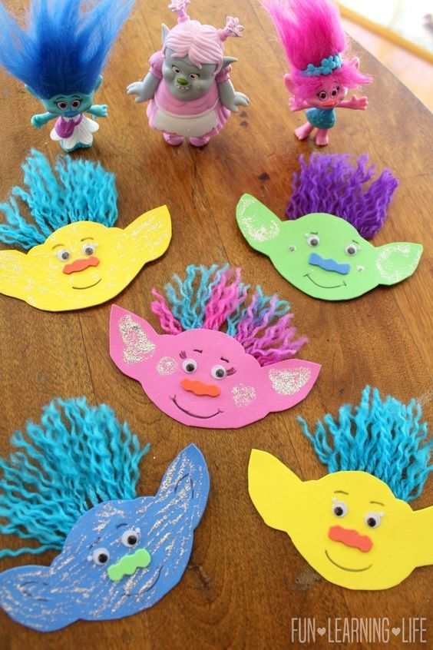](http://funlearninglife.com/2017/02/troll-magnet-trolls-party-blu-ray-edition/)[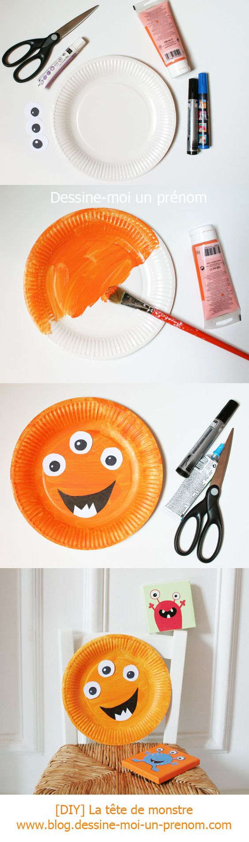](http://blog.dessine-moi-un-prenom.com/diy-fabriquer-des-monstres-en-carton/)[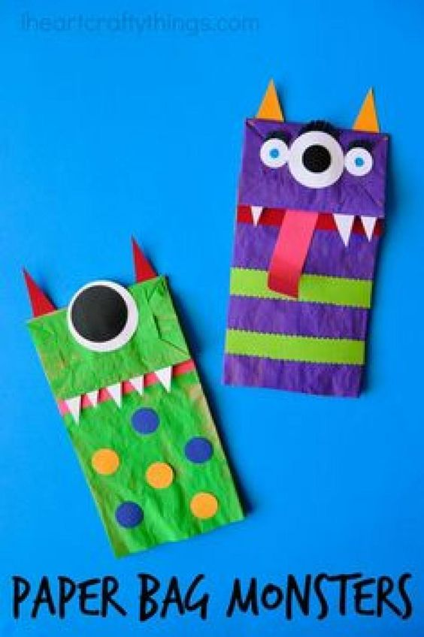](http://www.trucsetbricolages.com/brico-enfant/13-magnifiques-modeles-de-marionnettes-a-bricoler-avec-les-enfants)**

**[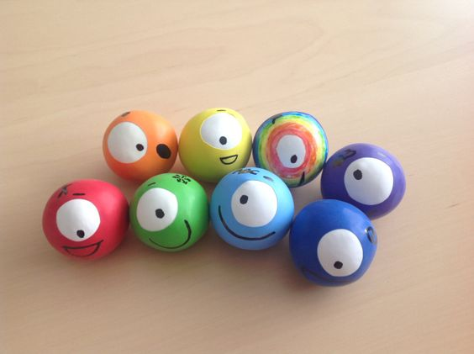](https://octofundotorg.wordpress.com/activites/bodyfun/balle-anti-stress/)**

**[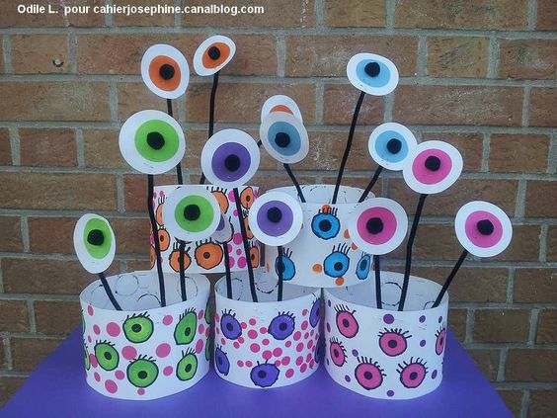](http://cahierjosephine.canalblog.com/archives/2014/01/12/28918685.html#utm_medium=email&utm_source=notification&utm_campaign=cahierjosephine)**

**[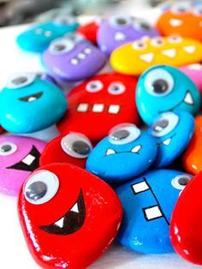](http://www.momes.net/Bricolages/Objets-a-fabriquer/Petits-objets-a-creer/Les-monstres-galets-magnets)[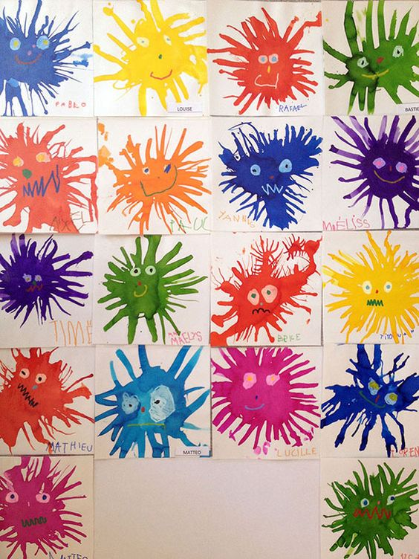](http://forums-enseignants-du-primaire.com/topic/284037-psmsgs/page-30?hl=%20psmsgs)**

**[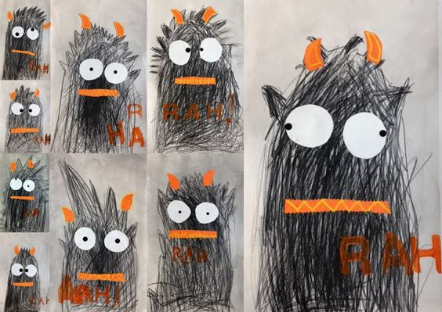](http://lespetitestetesdelart.blogspot.fr/)[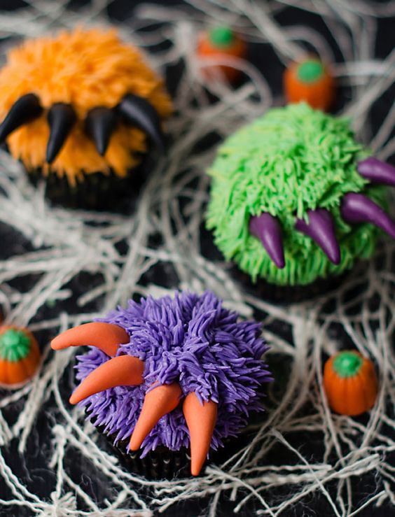](http://www.w3sh.com/2014/10/31/20-idees-de-cupcakes-pour-decorer-votre-repas-dhalloween/)**

**[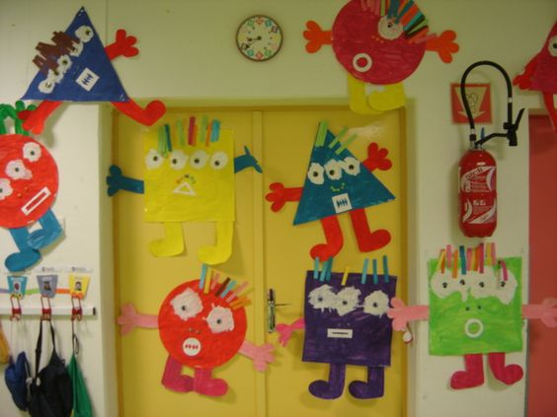](http://www.mat-gide-magny.ac-versailles.fr/spip.php?article41)**

**[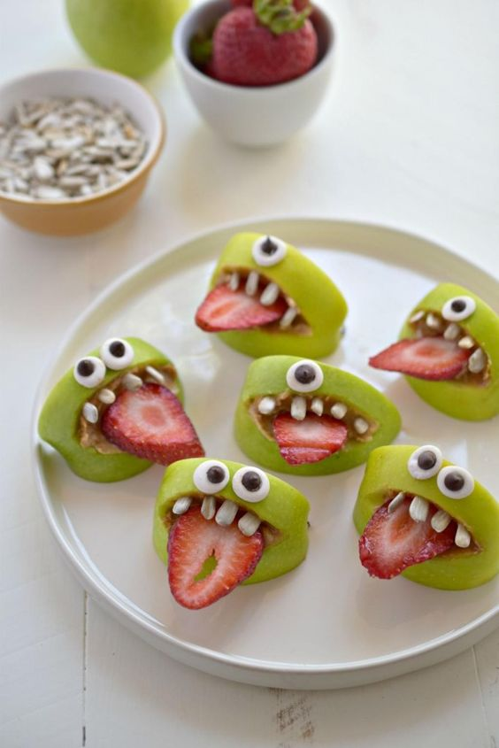](http://www.trucsetbricolages.com/cuisine/une-collation-sante-et-sans-beurre-d-arachide-pour-halloween-plus-une-recette-pour-les-petits-yeux/)**

**[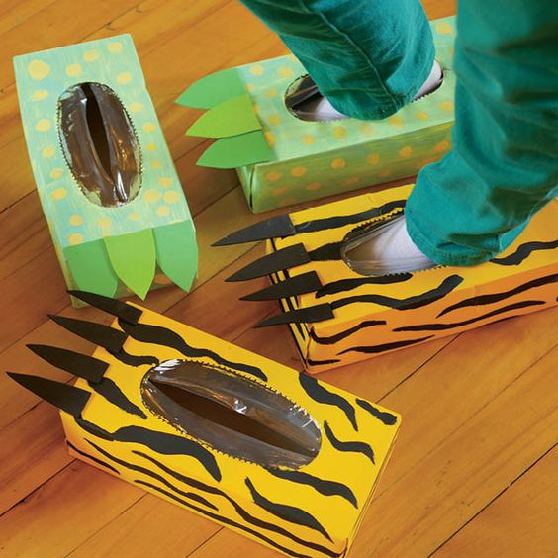](http://enfantsquebec.com/2015/01/23/brico-boite-droles-pieds/)**

**[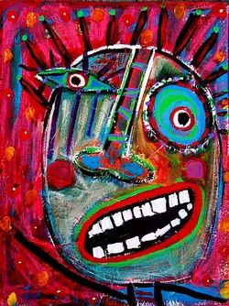](http://poppiloops.weebly.com/1/post/2010/11/tracey-ann-finley.html)[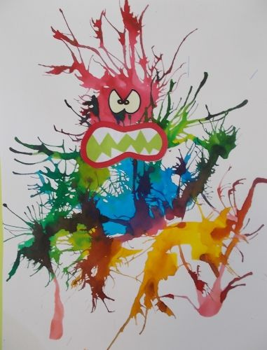](http://ducotedechezdelph.hautetfort.com/archive/2016/03/12/des-monstres-encore-5773150.html)**

**[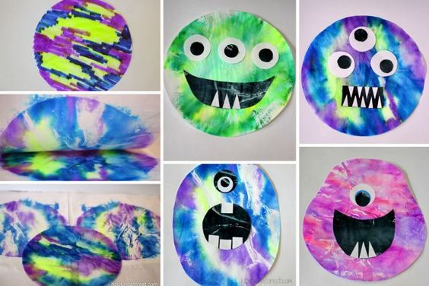](http://www.mamanpourlavie.com/loisirs-creatifs/bricolage--projets-et-experiences/11639-bricolages-avec-des-filtres-a-cafe.thtml?page=6)**

**[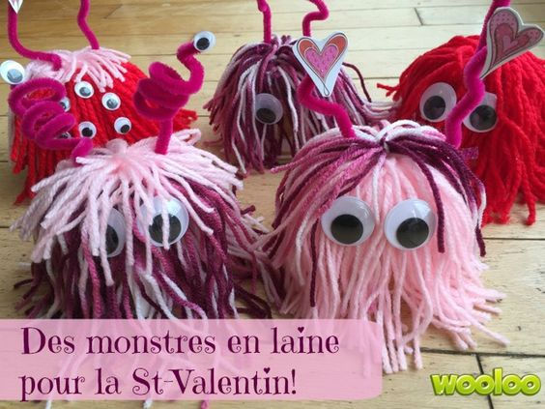](http://wooloo.ca/2016/01/12/des-monstres-en-laine/)[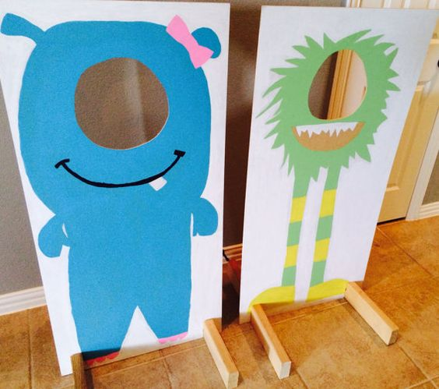](https://www.etsy.com/fr/listing/248613568/photomaton-de-monstre?utm_source=OpenGraph&utm_medium=PageTools&utm_campaign=Share)**

**[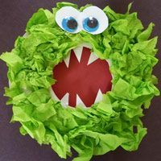](https://s-media-cache-ak0.pinimg.com/originals/92/80/af/9280af4183ba42d6a3dfb9256f54d36b.jpg)[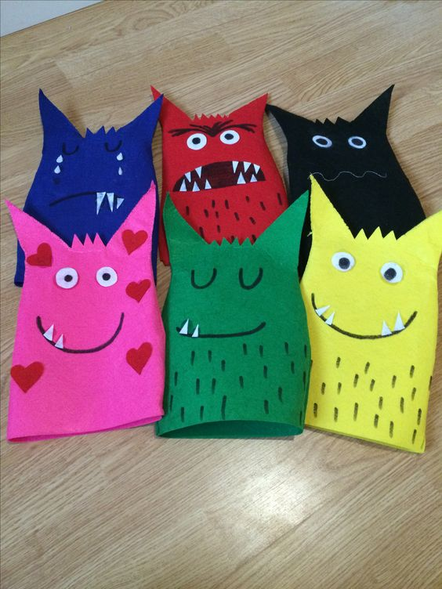](https://s-media-cache-ak0.pinimg.com/originals/b7/06/79/b7067919f3536cf71549a78082ecbcf5.jpg)[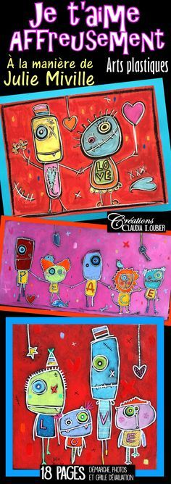](https://www.teacherspayteachers.com/Product/St-Valentin-arts-plastiques-Je-taime-Affreusement--2308088)**

**[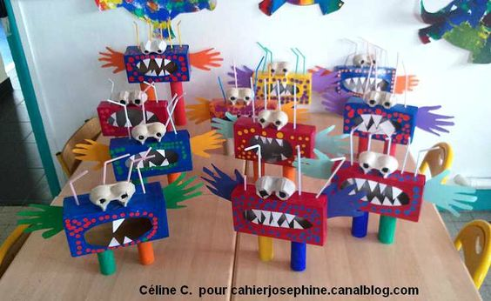](http://cahierjosephine.canalblog.com/archives/2014/10/15/30770237.html#utm_medium=email&utm_source=notification&utm_campaign=cahierjosephine)**

**[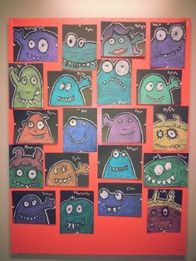](http://www.ressources-pedagogiques.be/journal-de-classe-enseignant/)**

**[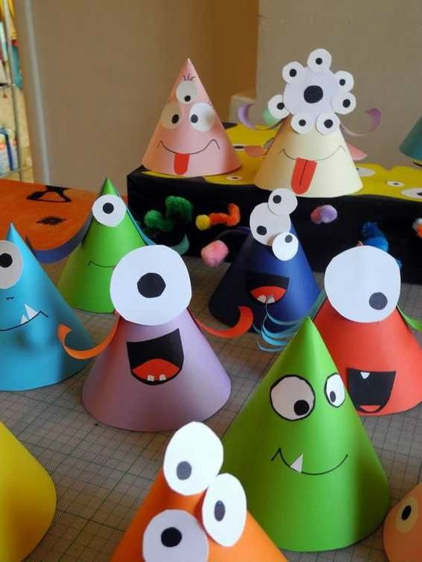](http://cahierjosephine.canalblog.com/archives/2014/10/12/30707492.html)**

**[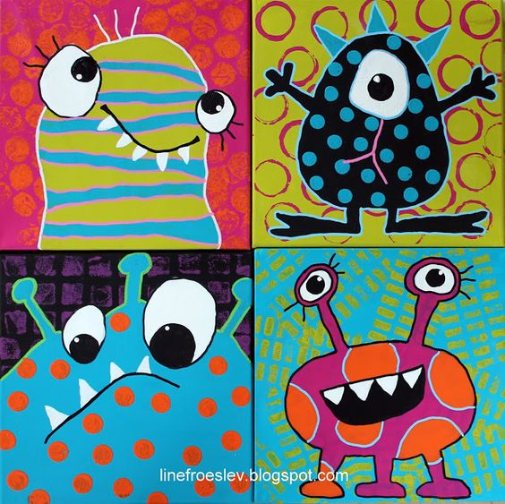](http://linefroeslev.blogspot.com.es/2016/08/mal-et-monster-monsterfed-billedkunst.html)[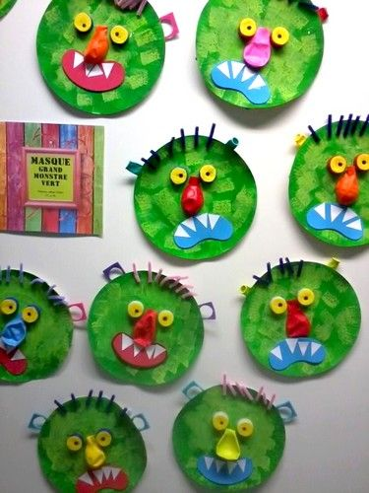](http://images.google.fr/imgres?imgurl=http://sites79.ac-poitiers.fr/germond-rouvre/sites/germond-rouvre/IMG/jpg/01_masques_de_monstres_verts_Ps_et_MS.jpg&imgrefurl=http://sites79.ac-poitiers.fr/germond-rouvre/spip.php?article259&h=500&w=375&tbnid=CBat5WmoH43S1M:&docid=7jBW2PjFegs7JM&ei=4by2V_u4Is6ogAaYpaboDw&tbm=isch&iact=rc&uact=3&dur=703&page=2&start=48&ndsp=59&ved=0ahUKEwi7rePcgc3OAhVOFMAKHZiSCf0QMwiDASgwMDA&bih=955&biw=1920)[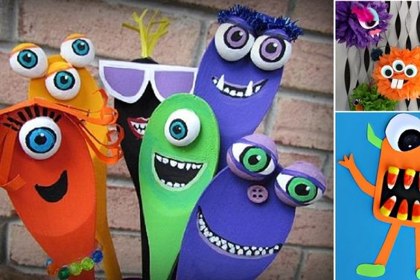](http://www.trucsetbricolages.com/bricolages/16-magnifiques-bricolages-de-monstres-a-faire-avec-les-enfants/)[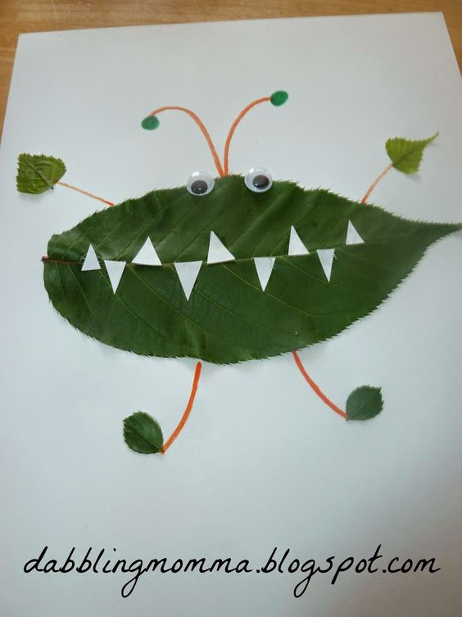](http://dabblingmomma.blogspot.com/2014/07/leaf-creatures.html#_a5y_p=1948686)[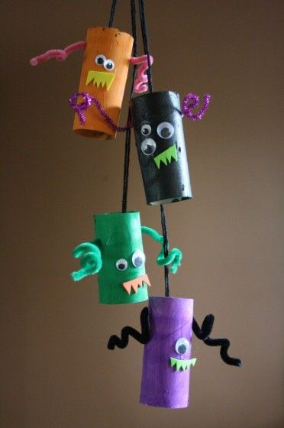](http://happyhooligans.ca/monster-mobile/)[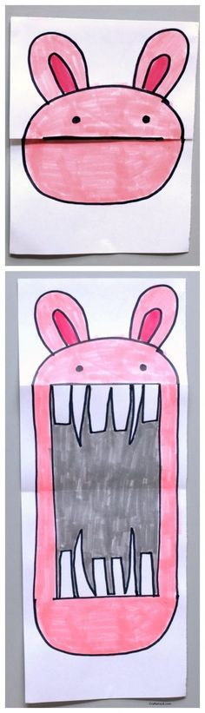](http://craftwhack.com/surprise-ferocious-beings-paper-project/)[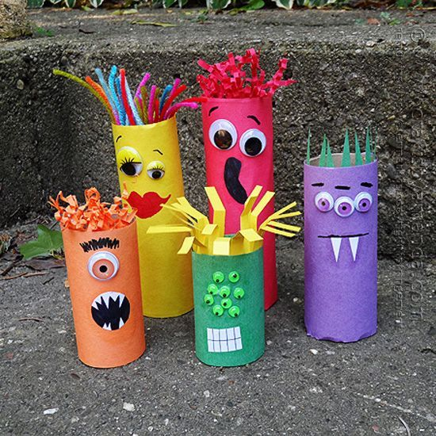](http://craftsbyamanda.com/2014/08/55-cardboard-tube-crafts-kids.html)**