Winter Olympic Sports
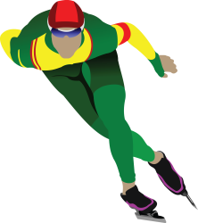
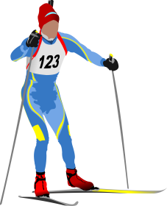

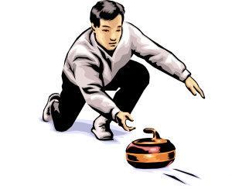
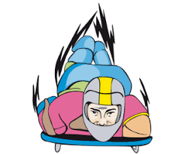
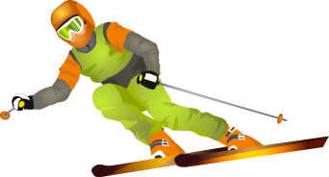

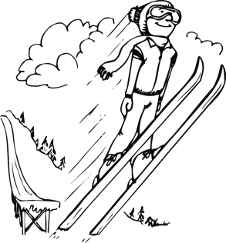
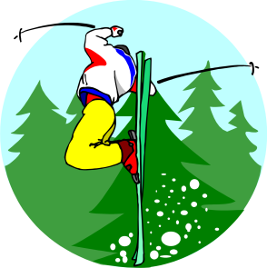
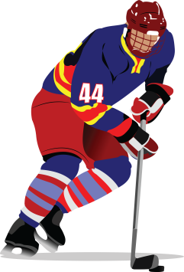
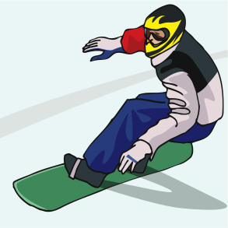

Use the words to identify each Winter Olympic Sport.
Alpine Skiing | Bobsleigh | Cross-Country Skiing
Curling | Figure skating | Freestyle Skiing
Hockey | Luge | Skeleton
Ski jumping | Snowboarding | Speed skating

True or false
Use a check mark to communicate your answers. |  | True | False
1 | Figure staking and ice hockey were originally part of the Summer Olympics.
2 | Horse and dogs once participate in the Winter Games.
3 | Canada has captured more gold than any country at the Winter Olympics.
4 | Two men’s hockey teams from the United States arrived at the 1949 Games.
5 | The Summer Olympics and Winter Olympics used to be held in the same year.
6 | Curling, figure skating competition used to be outside.
7 | Mexico hosted the Winter Olympics.
8 | The first Winter Olympic Games were in Chamonix, France in 1924
9 | Jamaica competed in the Bobsleigh in 1988 at the Winter Olympics in Calgary, Canada.
10 | Many countries send only one athlete at the Winter Olympics.
11 | The Mascot for the 2018 Winter Olympics is a white panda named Soohorang.
12 | The 2018 Winter Olympics will be held in Pyeongchang, South Korea.

Explanations
- True. Two of the most popular sports on ice actually made their Olympic debuts during the Summer Games, albeit at more seasonable times of the year. Back when Olympic programs stretched over the course of months, men’s, women’s and pairs figure skating were first held in October 1908 at the London Summer Games. Figure skating returned along with ice hockey in April 1920 as part of the Summer Olympics program in Antwerp. Both sports shifted to the Winter Olympics when they debuted in 1924
- True. While equestrian events have been a long-time staple of the Summer Olympics, horses were also present at the 1928 Winter Games in the skijoring event in which competitors on skis raced each other as they were towed by riderless horses. Skijoring was a demonstration sport, so no medals were awarded, and the sport never returned to the Olympics. Canines, however, appeared during the 1932 Lake Placid Winter Games as part of the demonstration sport of sled dog racing.
- False. It is Norway. Although it is a country of just five million people, a similar population to Colorado, Norway entered the Sochi Games with a record avalanche of 107 gold medals and 303 total medals. It is one of only three countries—including Austria and Liechtenstein—that has won more medals in the Winter Games than in the Summer Olympics.
- True. Talk about awkward. Two teams, backed by rival hockey associations, arrived at the 1948 St. Moritz Winter Games claiming they were the rightful squad to compete for the United States. The team backed by the American Hockey Association, which included professionals, was ultimately recognized as the official American team, while the strictly amateur squad sponsored by the Amateur Athletic Union and the United States Olympic Committee sat on the sidelines and even booed their compatriots from the stands.
- True. The last year that it occurred was in 1992. After this, they alternated, being two years apart.
- True.
- False. No country in the Southern Hemisphere has ever hosted a Winter Olympics.
- True
- True, The Jamaican national bobsleigh team represents Jamaica in international bobsledding competitions. The team first gained fame during their debut in the 1988 Winter Olympic Games in Calgary, Alberta,^{[1]} where they were seen as underdogs as they represented a tropical nation in a winter sport. The team returned to the Winter Olympics again in 1992, 1994, 1998, 2002, and 2014. The team failed to qualify for the 2006 and 2010 Winter Olympics. Led by driver Winston Watts, Jamaica qualified for the 2014 Winter Olympics in the two-man bobsled
- True. While countries like the United States, Canada and Russia have sent many athletes to the games (230, 220 and 225 respectively), 18 nations sent just one athlete representing them in Sochi. They are: Zimbabwe*, Kyrgyzstan, Pakistan, Tajikistan, Timor-Leste*, Malta*, Cayman Islands, Mexico, Venezuela, U.S. Virgin Islands, Nepal, Luxembourg, Bermuda, Paraguay*, British Virgin Islands, Hong Kong, Philippines and Tonga
- False. The Mascot for the 2018 Winter Olympics is a white tiger named Soohorang.
- True. From February 9 to February 25

